**Ideation Phase Define the Problem Statements**

|  |  |
| --- | --- |
| Date | 03 October 2022 |
| Team ID | PNT2022TMID35002 |
| Project Name | AI-Powered Nutrition Analyzer For Fitness Enthusiasts |
| Maximum Marks | 2 Marks |

**Problem Statement :**

Food is essential for human life and has been the concern of many healthcare conventions. Nowadays new dietary assessment and nutrition analysis tools enable more opportunities to help people understand their daily eating habits, exploring nutrition patterns and maintaining a healthy diet. Nutritional analysis is the process of determining the nutritional content of food. It is a vital part of analytical chemistry that provides information about the chemical composition, processing, quality control and contamination of food.

The main aim of the project is to build a model which is used for classifying the fruit depending on the different characteristics like colour, shape, texture etc. Here the user can capture the images of different fruits and then the image will be sent to the trained model. The model analyses the image and detects the nutrition based on the fruits like (Sugar, Fibre, Protein, Calories, etc.).

**Problem Statement Template:**

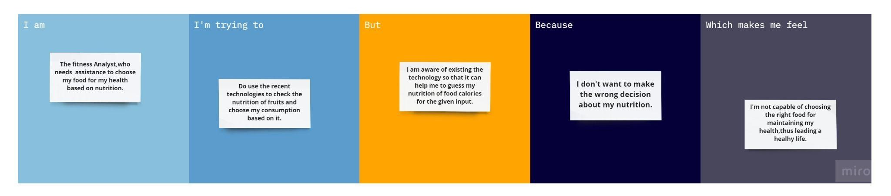

|  |  |
| --- | --- |
| **I am (Customer)** | **The fitness Analyst,who needs assistance to choose my food for my health based on nutrition.** |
| **I’m trying to** | **Do use the recent technologies to check the nutrition of fruits and choose my consumption based on it.** |
| **But** | **I am aware of existing technology so that it can help me to guess my nutrition of various fruits for the given input**. |
| **Because** | **I don't want to make the wrong decision about my nutrition.** |
| **Which makes me feel** | **I'm not capable of choosing the right food for maintaining my health,thus leading a healthy life**. |